
Software Engineering Department
Braude College of Engineering
Capstone Project Phase A - 61998

FirmOffice
Project code: 26-2-D-12
Supervisor:
Dr. Natali Levi-soskin

Authors:
Matan Ben Hamo
m63856132@gmail.com
Lior Esterkin
Esterkin.lior@gmail.com

GitHub Link:
https://github.com/LiorEsterkin/FirmOffice.git

Abstract

This project presents the design and architecture of FirmOffice, a cloud-based Integrated Accounting Management and Document Centralization System developed to tackle the operational inefficiencies caused by fragmented document ingestion channels in accounting firms. Tailored for the real-world client "Levi, Unger, Slilat CPAs", the system unifies three major ingestion paths: direct web uploads, automated email attachment extraction via Gmail API, and real-time capture from WhatsApp webhooks, into a single, secure interface. Utilizing Google Cloud Vision API for Optical Character Recognition (OCR) coupled with a custom rule-based Regex parser, the platform automatically extracts critical financial metadata and categorizes files into predefined accounting taxonomy. The project ultimately aims to significantly reduce the cognitive load on financial professionals, minimize the need for manual data entry, improve audit traceability, and prevent missed regulatory deadlines through an automated tracking and alert system.

Table of Contents
Abstract 1
Table of Contents 2
1. Introduction 3
2. Related work 4
2.1 The Multi-Channel Ingestion Problem and Information Overload 4
2.2 Architectural and Technical Limitations of Core Software 4
2.3 Evaluation of Existing Market Categories and the Solution Gap 5
2.4 Technologies Used 5
3. Working with a real-world client 7
3.1 Client Engagement 7
3.2 Requirements 8
4. Engineering Process 10
4.1 Development Methodology 10
4.2 Engineering Stages 10
4.3 Potential Challenges 11
5. Product 12
5.1 Product Description 12
5.2 Diagrams 12
5.3 System Architecture 14
5.4 Tier Breakdown 14
5.5 Key Algorithms 16
5.6 Planned data Structures 17
5.7 System Interfaces 18
6.Testing & Evaluation 19
6.1 Acceptance test 19
6.2 Key Performance Indicators - Evaluation Metrics 20
7. References 21
8. Appendix 22
A. Interview 22

1. Introduction

Digital transformation has shifted the accounting domain away from physical ledgers toward cloud-based workflows [10]. However, this transition introduces a major operational challenge: severe fragmentation of data collection channels. Modern accounting practices face a continuous daily chase after financial documents, which arrive uncoordinated across platforms like WhatsApp and email [10]. Instead of providing high-level financial consulting, professionals spend disproportionate billable hours acting as manual data integrators [10]. This administrative disorganization disrupts audit trails, compromises data traceability, and increases cognitive load, leading to human errors, data loss, and regulatory delays [7].
Existing financial systems focus almost exclusively on internal bookkeeping mechanics, leaving a vacuum regarding automated external document retrieval [4], [1]. They lack a dedicated framework to bridge the gap between daily customer messaging applications and the firm's ingestion process, creating disconnected information silos [11]. This bottleneck was highly evident during our field engagement with an active accounting firm, where manual file collection from fragmented sources hindered workflow scalability [5].
To resolve this, this project proposes a cloud-based Integrated Accounting Management and Document Centralization System. By unifying direct uploads, email extraction, and real-time WhatsApp capture into a single interface, the platform replaces the manual chase with an automated pipeline, transitioning firms toward proactive digital governance [7], [5], [4].
The remainder of this report is structured as follows. Chapter 2 discusses the motivation for our solution, existing market alternatives, and the technologies utilized. Chapter 3 describes our work with a real-world client. Chapter 4 outlines the engineering process, core challenges, final solution, system architecture, diagrams, and algorithms. Chapter 5 presents our expected testing and evaluation process. Finally, the complete client interview transcript is attached in the Appendix.

2. Related work

2.1 The Multi-Channel Ingestion Problem and Information Overload
The core operational bottleneck in modern accounting practices stems from the widening gap between the massive volume of digital data generated by clients and the firm’s capacity to systematically collect and process it [10]. Today, accountants no longer receive financial documentation through a single, controlled stream. Instead, essential inputs like receipts, invoices, and bank statements arrive through a disparate, non-integrated array of channels including explicit system uploads, unstructured email threads, and instant messaging platforms like WhatsApp.
This decentralized distribution forces accounting professionals to act as manual data integrators, spending excessive billable time chasing records rather than performing high-level financial analysis [10]. Operating within such unstructured environments heavily inflates the cognitive load imposed on financial professionals [7]. When critical business documentation is scattered across informal messaging applications and detached email streams, the risk of data siloing increases, leading to a severe lack of traceability, chronological audit trail failures, human error, and missed regulatory deadlines [7].
Furthermore, the manual effort required to constantly monitor and extract attachments from continuous, informal streams limits business scalability. While instant messaging tools like WhatsApp optimize client-side convenience, they lack the administrative oversight, security protocols, and structured indexing necessary for compliant financial archiving, validating the need for automated aggregation mechanics [9].

2.2 Architectural and Technical Limitations of Core Software
From a technical perspective, the challenges of document centralization are further exacerbated by limitations in existing Accounting Information Systems (AIS). Modern accounting requires robust information architectures to ensure data integrity and secure reporting workflows [5]. However, traditional accounting software remains structurally rigid. These legacy platforms are designed almost exclusively to support back-end compliance mechanics and double-entry bookkeeping for the internal accountant, offering no direct, intuitive entry points or ingestion portals for clients [1]. Consequently, they remain incapable of dynamically interacting with external, lightweight communication streams.
While enterprise-level systems (such as comprehensive ERPs) attempt to resolve internal friction by consolidating workflows into a single repository, their high deployment costs and architectural complexity often alienate smaller accounting practices [1]. More importantly, these rigid corporate frameworks lack the agility needed to interface directly with informal client communication networks. Without an automated, specialized ingestion framework to capture documents at the point of origin, migrating to distributed web or cloud platforms simply shifts the issue, creating new, isolated information silos rather than a cohesive data ecosystem [11]. To ensure financial information quality, data velocity, and security, a firm's operational workflow must be anchored by automated pipeline integration that bridges daily customer interaction channels with a centralized data repository [5], [11].

2.3 Evaluation of Existing Market Categories and the Solution Gap
A critical evaluation of the contemporary accounting market reveals a deeply fragmented software landscape divided into distinct, isolated categories, where each addresses only a partial segment of the document ingestion lifecycle. Traditional, compliance-centric legacy platforms, such as "Hashavshevet" or QuickBooks, offer immense functional depth regarding double-entry bookkeeping and regulatory reporting. However, their structural complexity and steep learning curves make them entirely inaccessible to end clients [1]. The primary failure of these legacy systems is their rigid internal focus on compliance mechanics, which renders them incapable of flexibly capturing unstructured, external document streams initiated by clients.
In response to this rigidity, client-oriented cloud applications, such as Morning (formerly Green Invoice), emerged to streamline invoice creation and expense tracking, providing a basic data-export window for the accountant [4]. Nevertheless, these tools only manage structured inputs generated directly within their own ecosystems, leaving day-to-day document chasing, missing file clarifications, and continuous client coordination to occur entirely outside the system via detached emails or WhatsApp chats.
To bridge these inefficiencies, specialized auxiliary tools like Dext or Finbot utilize OCR and artificial intelligence algorithms to scan physical receipts, transmitting validated data directly into the accounting software [7]. While these tools reduce manual data entry, they function strictly as isolated, supplementary utilities rather than complete platforms. They fail to provide a unified, bidirectional, and secure communication framework where a firm can view and verify all incoming client data channels simultaneously.
This highlights a severe, persistent gap: the lack of a single, centralized platform capable of uniformly organizing all client financial documentation under one roof. The absence of secure connectivity between day-to-day communication mechanisms and a unified ingestion framework compromises data integrity and causes systemic delays [5]. This critical gap validates the necessity of the proposed platform, which centralizes form uploads, automates email ingestion, and incorporates direct WhatsApp extraction into a single, synchronized repository.

2.4 Technologies Used

2.4.1 OCR - Optical Character Recognition Using Google Cloud Vision API
Optical Character Recognition (OCR) is a technology used to convert text that appears in images, scanned documents, or photographed documents into machine-readable text [3]. OCR systems are commonly used for digitizing printed documents and extracting textual information from visual inputs [3]. Google Cloud Vision OCR is a cloud-based OCR service that enables text detection and extraction from images and document-based inputs, making it suitable for processing structured and semi-structured documents such as receipts and invoices.
Google Cloud Vision OCR works by receiving an image or document file and analyzing it using cloud-based machine learning models [6]. The service can detect textual content and return the extracted text together with additional structural information, such as text blocks, paragraphs, words, and bounding boxes [6]. This output can later be used by external systems for further processing, such as document analysis, information extraction, and classification.

2.4.2 Web Hooks
Webhooks are an event-driven communication mechanism that enables real-time, automated data transfer between external platforms and our system's server [12]. Unlike traditional polling methods, where the server must repeatedly and inefficiently query the WhatsApp API to check for new data, a Webhook operates on a "push" model [12]. The moment a client sends a document via WhatsApp, the platform instantly triggers an HTTP POST request containing the message payload and file metadata to a designated endpoint on our server. We utilize this technology because it eliminates unnecessary network overhead, optimizes resource consumption, and ensures that client documents are captured, processed, and ingested into the management system with zero latency.

2.4.3 Non-Relational Database Architecture
This database stores and organizes all client information, communication logs, and financial records in one centralized location. Instead of using rigid tables with fixed rows and columns, a NoSQL database stores data in flexible, JSON-like documents [2]. When data arrives from different sources like WhatsApp or direct web uploads, it can be saved instantly even if the format varies [2]. The database uses advanced indexing to fetch records quickly and features real-time listeners that immediately sync updates across both the accountant and client dashboards.

2.4.4 Modern Web Architecture
React and Next.js are used to build fast, secure, and interactive web dashboards for both the clients and the accounting firm. React divides the user interface into small, reusable components that update automatically whenever the underlying data changes, ensuring a smooth user experience [8]. Next.js enhances this by rendering pages on the server side (SSR) before sending them to the browser, which improves loading speeds and data security [8]. Together, they handle frontend routing and securely connect the user interface to our backend APIs and database.

3. Working with a real-world client

3.1 Client Engagement
This project is developed for a real-world accounting firm facing a genuine and critical challenge in its daily operations. To fully understand the client's needs, we conducted a series of preliminary discussions, followed by an in-depth, face-to-face interview. This chapter outlines the insights gained from these sessions and highlights the main operational pain points identified during the process. For full transparency, the complete interview transcript is attached at the end of this chapter.

3.1.1 Client Description
Levi, Unger, Slilat Certified Public Accountants serves as the real-world client for this project. Located in the northern region and Haifa area, the firm provides comprehensive accounting, tax consulting, and financial services to a wide range of Israeli businesses.
The firm currently consists of 15 employees, including partners, certified public accountants, bookkeepers, and administrative staff. Due to its diverse services and large client base, the firm regularly processes a high volume of financial documents, such as invoices, receipts, and tax forms. This intensive operational environment makes the firm an ideal client for the proposed system, which directly addresses their critical need for a centralized, organized, and reliable process to collect, track, and manage client documents.

3.1.2 Current Work Process
The client firm currently manages financial documents through a predominantly manual workflow that relies on several submission channels. Since the firm operates in direct interaction with the Israeli Tax Authority, both the firm and its clients are required to comply with strict reporting deadlines. Consequently, the timely submission, handling, and processing of accounting documents constitute a critical component of the firm’s daily operations. At present, a considerable portion of the firm’s clients submit their documents physically at the office. In other cases, documents are sent by email and WhatsApp, despite these not being the firm’s preferred communication channels for official document submission. In certain cases, clients may also deliver physical documents outside the firm’s working hours, creating additional difficulties in tracking, controlling, and documenting the submission process.
The firm receives various types of financial and tax-related documents, including tax invoices, receipts, income reports, expense documents, withholding tax approvals, documents required for annual reports, forms submitted to or received from tax authorities, capital declarations, and additional supporting documents. However, within the scope of this project, the initial implementation will focus on two primary document types: tax invoices and tax invoice-receipts. This focus enables the project to maintain a clearly defined and feasible implementation scope, while still addressing document types that are frequently submitted by clients and are central to the firm’s accounting workflow.
The current workflow within the firm is characterized by a lack of centralization and inconsistent customer interaction, which negatively impacts operational efficiency. Most clients submit their financial documents physically, in a fragmented and non-continuous manner (either as isolated documents or in bulk), and often past the required schedule. As a result, documents belonging to the same client are received by different staff members at various times, leading to a situation where multiple accountants concurrently handle the same client portfolio without proper coordination. Only after all required documents are gathered a stage usually performed under the pressure of the strict Tax Authority deadlines, does the accountant managing the case perform a comprehensive review of the materials and submit them to the Income Tax and VAT systems. This decentralized and manual process creates duplicate work, complicates uniform tracking, and increases the risk of reporting delays.

3.1.3 Client Interview
Interviewee: Managing Partner, "Levi Unger Saliat" Accounting Firm.
Objective: To understand existing workflows, identify operational bottlenecks, and define functional requirements for the proposed document management system.
"The interview is attached as Appendix A"

3.2 Requirements

3.2.1 Functional Requirements (FR)
- The system shall automatically scan and retrieve incoming documents from three business WhatsApp accounts and one central Gmail inbox.
- The system should provide a dedicated web interface for end-clients to manually upload and drag-and-drop financial records into their profiles.
- The system shall feature a "Submission Complete" button for clients that freezes further uploads and serves as an operational trigger for the firm.
- The system shall instantly notify the assigned accountant within the management interface as soon as a client confirms their monthly submission.
- The system automatically detect late submissions past the monthly cutoff date and trigger immediate alerts to the accountant via Email and WhatsApp.
- The system shall automatically categorize and sort all ingested files into three predefined buckets: Income, Expenses, or Miscellaneous.
- The system shall utilize OCR to extract metadata fields including document date, type, invoice number, Israeli allocation number, recipient name, and amounts.
- The system shall perform automated quality checks, reject blurry or unreadable uploads, and automatically prompt the client to resubmit a clear copy.
- The system shall automatically generate and distribute scheduled reminders to clients via WhatsApp, SMS, or Push notifications prior to the cutoff deadline.
- The system shall provide a verification checkbox next to each document in the accountant's workspace to manually flag it as "Successfully Processed".
- The system will provide the client with the option to open an inquiry or send a request for a meeting at the accounting firm.

3.2.2 Non-Functional Requirements (NFR)
- The system shall enforce a flat team permission model, granting all internal staff unrestricted read and write access to all client records.
- The system shall guarantee absolute logical data isolation (Multi-Tenancy) between end-clients to strictly prevent any cross-client data exposure.
- The system shall maintain an operational availability (Uptime) of at least 99.5% during standard business hours.
- The architecture shall support concurrent ingestion pipelines for up to 500 active clients and store up to 50,000 documents without performance degradation.
- The system shall render management dashboards and cross-organizational analytics screens in less than 2.0 seconds under standard network conditions.
- The user interface shall be fully responsive and optimized for mobile browsers across all major platforms without requiring a native app installation.
- The system shall execute encrypted daily backups to the cloud, adhering to a disaster recovery policy with a Recovery Point Objective (RPO) of 24 hours.
- The system shall implement robust API fault tolerance by queuing failed tasks and executing retry logic during WhatsApp or Gmail connectivity issues.
- The system shall maintain an immutable, read-only chronological audit log capturing all critical administrative actions and system events.
- The system shall comply with the Israeli Privacy Protection Regulations, enforcing full data encryption both at rest and in transit.
- The system will be suitable for use on both computers and smartphones.
- The system shall ensure that all user-facing content and interactions are appropriate and safe for use by the Haredi public, according to predefined cultural and religious suitability guidelines.

4. Engineering Process

4.1 Development Methodology
We adopted an Agile-inspired iterative approach, emphasizing flexibility, continuous validation, and incremental improvements. The motivation for this approach stems from:
- Frequent stakeholder input is required for tuning the document verification and status feedback mechanisms.
- Variability in document formats and communication channels (invoices, receipts, periodic bills via WhatsApp, Email, or manual uploads).
- High sensitivity of financial data and the critical need for absolute processing reliability and regulatory compliance.
Each development sprint in Semester B includes:
- Focused implementation of individual components (e.g., automated multi-channel ingestion, OCR text extraction, dynamic accountant dashboards).
- Unit testing and integration into the broader document processing pipeline.
- Early-stage user testing with the accounting firm's staff and feedback integration.

4.2 Engineering Stages

4.2.1 Semester A - Research & Design
- Review of accounting tech platforms and automated document ingestion workflows in the fintech sector.
- Study of OCR engines (e.g., Google Cloud Vision, Tesseract) and their suitability for parsing financial documents and Israeli invoice allocation numbers.
- Design of system blueprints, including use case diagrams, data flows, relational schemas, and multi-tenancy data isolation.
- UI/UX wireframing for the client mobile-responsive upload interface and the accountant's management dashboard.
- Documentation of system success criteria, latency KPIs, and Israeli privacy regulation assumptions.

4.2.2 Semester B - Development & Testing
- Frontend Interfaces: Development of a responsive web client for file uploads (PDF/Images) with a "Submission Complete" trigger, and a real-time tracking dashboard for accountants.
- Backend Ingestion & APIs: Implementation of webhook listeners to pull attachments from business WhatsApp accounts and Gmail, alongside late-submission alert dispatchers.
- OCR & Image Processing Pipeline: Integration of text extraction for financial metadata and image preprocessing filters to automatically detect and reject blurry uploads.
- Database & Cloud Storage: Secure architecture implementation for storing user profiles, extracted financial metadata, and system audit logs.
- Testing & Quality Assurance: Unit testing for ingestion queues and OCR modules, followed by a pilot phase utilizing real-world documents provided by the firm.

4.3 Potential Challenges

4.3.1 Consolidating Multi-Account Ingestion (3 Distinct WhatsApp Numbers)
- The Challenge: Routing and organizing incoming documents from three different office WhatsApp numbers into a single system, ensuring that each document is correctly assigned to the right client's folder regardless of which number they sent it to.
- The Solution: Implementing a unified backend logic that acts as a single endpoint for all incoming files, automatically extracting the sender’s phone number and matching it to the correct client profile in the database.

4.3.2 Token Limitations and Cost Optimization in Advanced AI Processing
- The Challenge: Overcoming context window token limitations and high API computing costs when utilizing advanced LLMs or large OCR payloads to scan text-heavy, multi-page financial documents or long conversation threads.
- The Solution: Employing strict text preprocessing, filtering out irrelevant document boilerplate metadata before feeding it to the AI, and leveraging cost-effective text-extraction layouts (like prompt-engineering techniques or hybrid OCR models).

4.3.3 Client Adoption and Human-Error Prevention (Simplifying the End-User UI)
- The Challenge: Ensuring that non-technical clients (especially from sectors less adapted to modern technology) actually cooperate with the system and understand how to upload documents correctly without making mistakes.
- The Solution: Designing an extremely simplified UI with only two main features (a clean drag-and-drop file uploader and a single "Submission Complete" button) to completely eliminate confusion.

4.3.4 Handling Large and High-Resolution Document Files
- The Challenge: Processing large document files, such as high-resolution smartphone images or scanned financial documents, which may significantly increase upload time, storage usage, OCR processing time, and overall system costs.
- The Solution: Implementing file-size validation, image compression, and preprocessing mechanisms before storing or analyzing documents, while maintaining sufficient quality for accurate OCR and AI-based document classification.

5. Product

5.1 Product Description
FirmOffice is a cloud-based document centralization platform designed to eliminate the manual chasing of financial records for accounting firms. The system automatically gathers client documents from three main channels: a responsive mobile-friendly web portal, automated email extraction via the Gmail API, and real-time capture from WhatsApp webhooks. Once ingested, the platform utilizes Google Cloud Vision OCR and a custom parsing engine to automatically extract critical metadata, sort files into predefined categories, and display them on a real-time dashboard for immediate accountant review and easy Excel export.

5.2 Diagrams

5.2.1 Use case diagrams
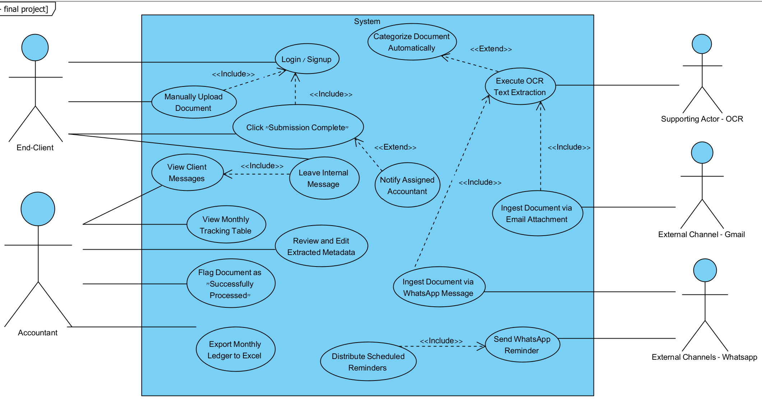

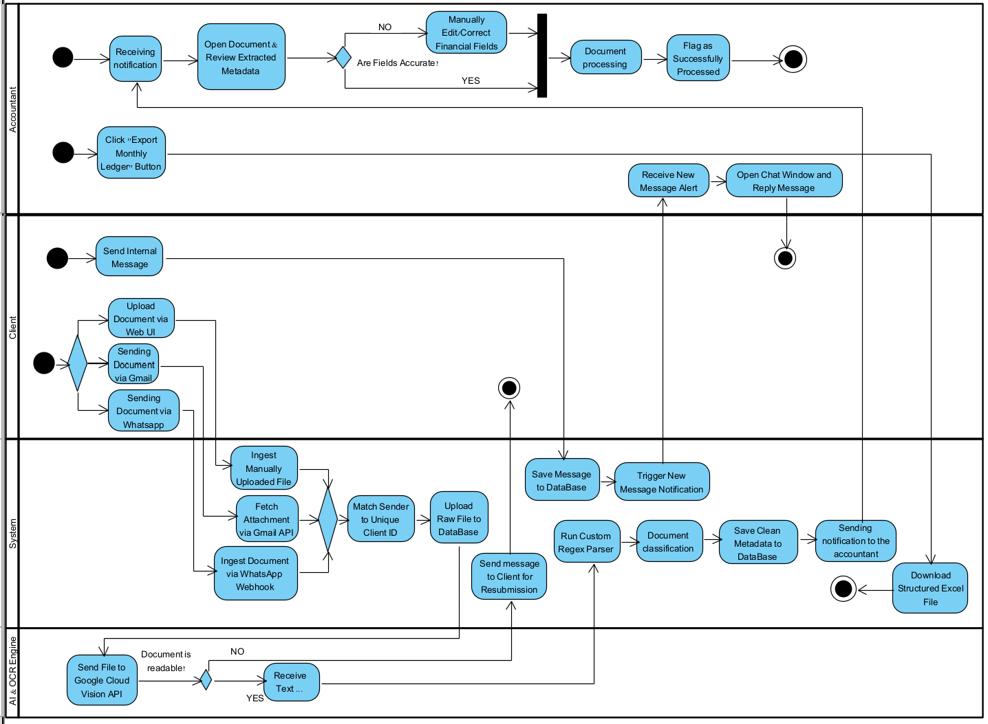
5.2.2 Activity diagrams

5.3 System Architecture
The system is built using a service-oriented, modular tiered architecture, which completely decouples the user interface, backend business logic, and the data layer. This structural design ensures high maintainability, straightforward testing, and the flexibility to replace individual components in the future without impacting the rest of the system.

5.3.1 System Architecture Diagram
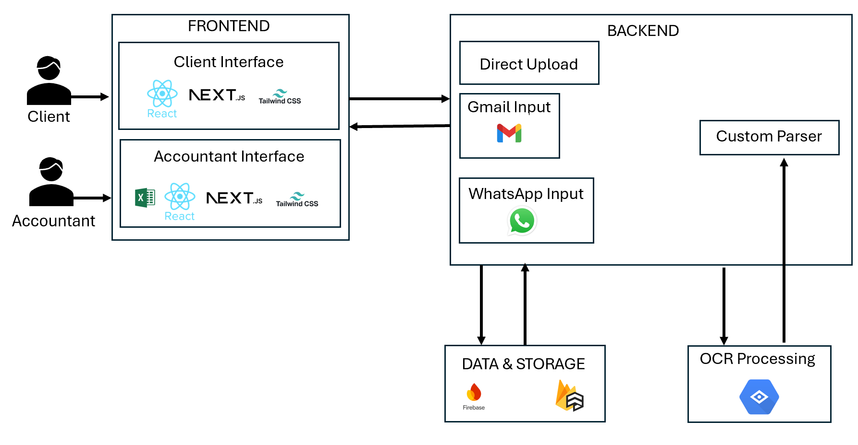

5.4 Tier Breakdown
5.4.1 Frontend
The user interface is built using React, Next.js and Tailwind CSS. It is divided into two main web interfaces:
  - Client Interface: A simple web form where clients can manually upload financial documents and invoices directly from their browser.
  - Accountant Interface (Dashboard): A central dashboard that displays a monthly tracking table of all extracted documents for each client. It allows the accountant to review data and export the processed monthly summaries into an Excel file.
5.4.2 Backend
The backend manages all the core business logic and is responsible for two main tasks:
- Event-Driven Ingestion Channels - The server concurrently handles incoming documents from three separate channels without active polling:
  - Direct Upload - Documents uploaded manually via the Client Web UI (sent as an HTTP POST request).
  - Email Input (Gmail API) - Google sends a secure Push Notification to our server whenever a new email arrives at the office inbox. The backend automatically fetches the email message and extracts the file attachments.
  - WhatsApp Input (WhatsApp Webhook) - A dedicated third-party gateway service manages the office WhatsApp number. When a client sends an invoice image, the service triggers a Webhook (an HTTP POST request) delivering the image URL and the sender’s phone number directly to our server.
- Processing & Parsing Engine (Google Vision & Custom Parser) - Once a file is captured from any channel, the backend executes the following procedural workflow:
  - Uploads the raw physical file (image or PDF) to a secure cloud storage bucket and generates a permanent file URL.
  - Dispatches the file to the Google Cloud Vision API using the DOCUMENT_TEXT_DETECTION feature. Google processes the image and returns the extracted text structured line-by-line.
  - Runs a custom, rule-based parser (using Regular Expressions - Regex) to scan the structured text lines. It programmatically isolates specific fields: the issuance date, business ID number, vendor name, while scanning for keywords like "Total" or "סה"כ" to extract the final financial sum.
5.4.3 Data & Storage Layer
Data persistence and storage are hosted and managed using Firebase:
- Object Storage: A secure cloud storage bucket that stores the original physical files (images and PDFs) for future reference.
- NoSQL Database / Cloud Firestore: A cloud-based NoSQL database used to store the logical document records and structured metadata generated by the system. Each document record is associated with a unique client ID and includes fields such as upload date, document type, OCR processing status, extracted financial data, vendor name, and a secure storage path referencing the original file in Cloud Storage.

5.5 Key Algorithms

5.5.1 Document Submission Algorithm
- Receives financial documents uploaded by clients through the web interface.
- Validates basic file properties, such as file type and file size.
- Stores the document securely and creates a linked database record.
- Assigns the document to the relevant client and reporting month.
- Sets the initial document status to Pending Processing.
5.5.2 Document Processing and Verification Algorithm
- Checks whether the uploaded document is readable, valid, and suitable for OCR processing.
- Sends the document to Google Cloud Vision OCR using:
  - TEXT_DETECTION for simple image files such as JPG or PNG.
  - DOCUMENT_TEXT_DETECTION for scanned documents, PDFs, invoices, receipts, or documents with structured layout.
- Receives the extracted text from Google Cloud Vision, including text blocks, lines, and confidence scores.
- Analyzes the extracted text to identify key accounting fields such as document type, date, invoice number, VAT amount, total amount, supplier name, and recipient name.
- Marks the document as Processed, Requires Manual Review, or Rejected according to OCR quality, extracted fields, and document validity.

5.5.3 Client Request and Appointment Management Algorithm
- Allows clients to open structured requests through the website instead of using WhatsApp.
- Links each request or appointment to the relevant client profile.
- Assigns a status such as Open, In Review, Waiting for Client, or Closed.
- Displays requests and appointment actions in the office dashboard.
- Reduces communication fragmentation and prevents client issues from being missed.
5.5.4 Accountant Workflow and Notification Algorithm
- Monitors new documents, failed processing attempts, open requests, and appointment requests.
- Creates dashboard notifications for actions that require office attention.
- Links each notification to the relevant client, document, or request.
- Allows the accountant to review, approve, reject, or complete the required action.
- Updates the operational status according to the accountant’s action.

5.6 Planned data Structures
"clients": {
"id": "uuid",
"name": "string",
"business_id": "string",
"email": "string", "phone": "string",
"created_at": "datetime"
}
"documents": {
"id": "uuid",
"client_id": "uuid",
"original_file_url": "string",
"source_channel": "email | whatsapp | manual_upload",
"document_type": "receipt | tax_invoice | other | unknown",
"status": "received | processing | requires_review | approved",
"confidence_score": "float",
"received_at": "datetime"
}
"extracted_fields": {
"id": "uuid",
"document_id": "uuid",
"supplier_name": "string",
"document_number": "string",
"document_date": "date",
"total_amount": "decimal",
"vat_amount": "decimal",
"currency": "string"
}

5.7 System Interfaces
5.7.1 User interface
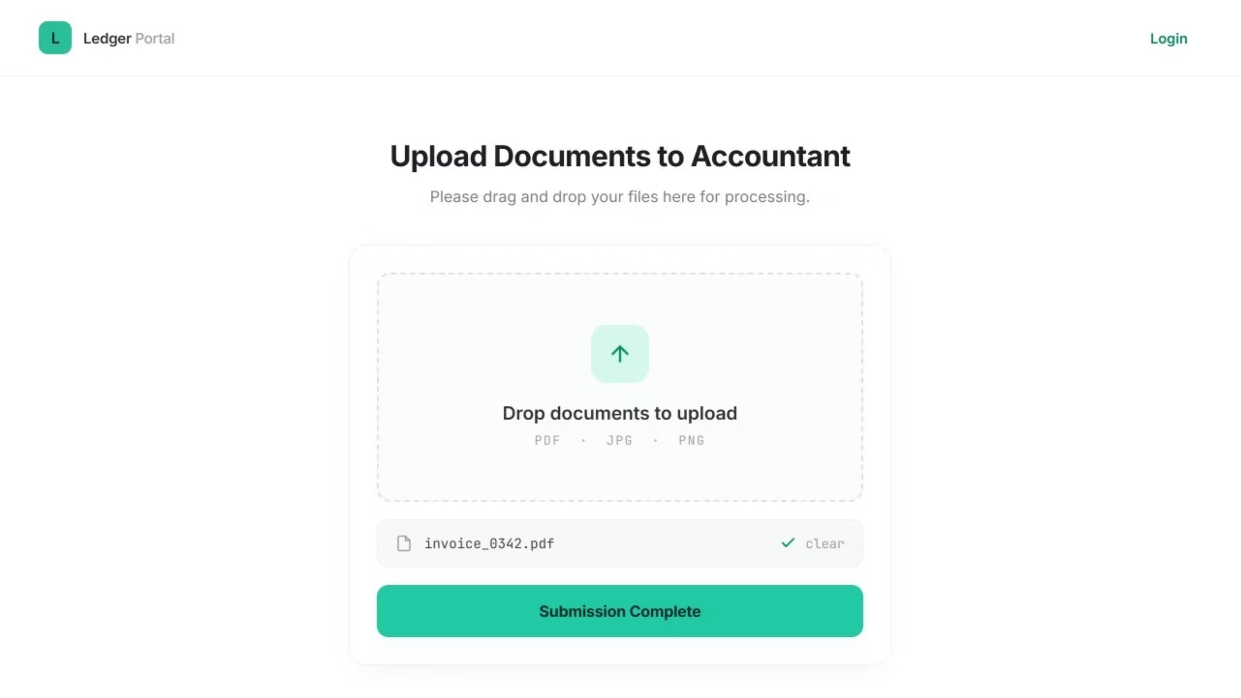
5.7.2 Accountant interface
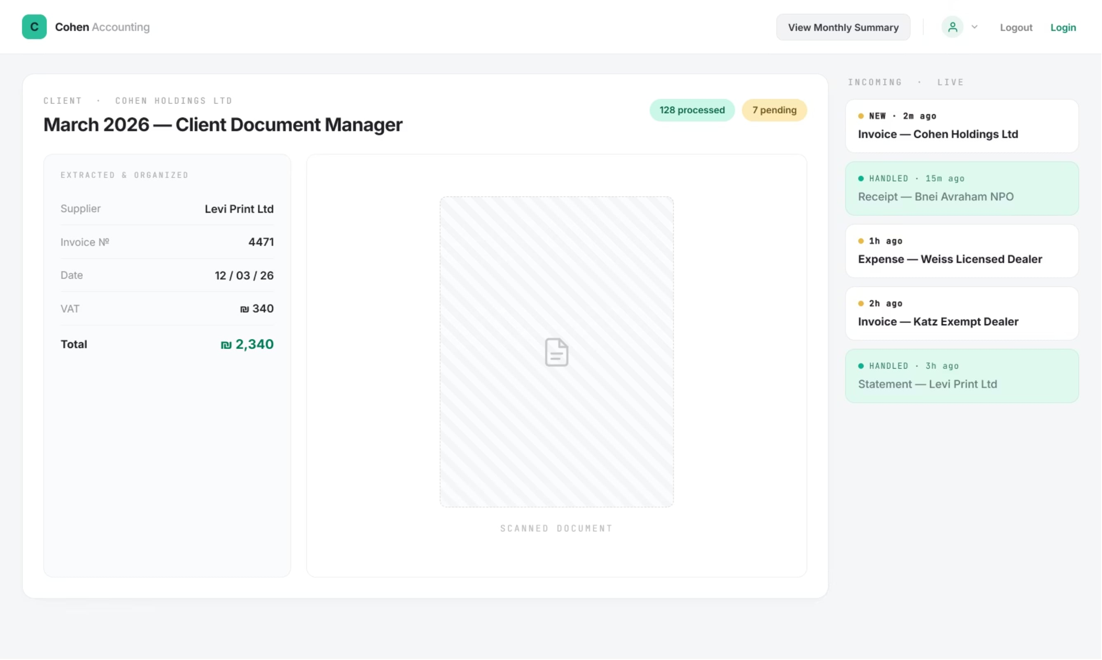

6.Testing & Evaluation

6.1 Acceptance test
Test | What Is Tested | How It Is Tested | Pass Condition
Client Login | Secure client authentication | Enter an existing client phone number or ID, then submit the verification code received by SMS or email | The client is authenticated and redirected to the main dashboard
Invalid Login Attempt | Access control and authentication failure handling | Enter an incorrect verification code or use a non-existing client identifier | The system blocks access and displays a clear error message
Document Upload | File upload functionality | Upload supported financial documents such as invoices, receipts, or PDFs through the client portal | The file is uploaded successfully and linked to the correct client
Metadata Creation | NoSQL document metadata storage | Upload a document and inspect the created metadata record | A metadata record is created with client ID, file URL, upload date, status, and document type
OCR Data Extraction | AI-based text extraction accuracy | Upload a clear invoice or receipt and run the OCR process | The system extracts key fields such as date, vendor name, total amount, and document type
Accountant Review Flow | Manual verification process | Open an extracted document in the accountant dashboard and approve or edit the detected data | The accountant can review, correct, and confirm the extracted information
New Document Notification | Accountant dashboard prioritization | Upload a new document from a client account | The client appears with a new document alert and is moved to the top of the client list
Invalid Document Detection | Document classification and input validation | Upload an image that is not a receipt, invoice, or supported financial document | The system identifies the file as an unsupported document and displays a clear error message

6.2 Key Performance Indicators - Evaluation Metrics
Category | Metric | Measurement Method | Target Value
Document Collection | Document Submission Completion Rate | % of requested client documents successfully uploaded through the portal or collected from connected channels | ≥ 90% per reporting period
OCR Accuracy | Key Field Extraction Accuracy | % of correctly extracted fields such as date, vendor name, total amount, document type, and invoice number | ≥ 85% for clear documents
Accountant Efficiency | Manual Data Entry Reduction | Compare average manual entry time before and after using the system | ≥ 50% reduction
Processing Performance | Document Processing Time | Time from document upload to OCR result display in the accountant dashboard | < 30 seconds per standard document
Review Workflow | Accountant Approval Rate | % of OCR-processed documents approved by the accountant without major corrections | ≥ 80%
Data Organization | Monthly Ledger Completeness | % of approved documents correctly assigned to the relevant client and month | ≥ 95%
System Reliability | Upload Success Rate | % of document upload attempts completed without system errors | ≥ 98%

7. References
[1] Adoption of enterprise resource planning (ERP) systems and cloud-based accounting software. (2024). ResearchGate. https://www.researchgate.net/publication/383304909_Adoption_of_enterprise_resource_planning_ERP_systems_and_cloud-based_accounting_software
[2] A survey and comparison of relational and non-relational database. (2021). International Journal of Computer Trends and Technology. https://d1wqtxts1xzle7.cloudfront.net/76957411/a-survey-and-comparison-of-relational-and-non-relational-database-libre.pdf
[3] Chaudhuri, A., Mandaviya, K., Badelia, P., & Ghosh, S. K. (2017). A survey on optical character recognition system. arXiv. https://arxiv.org/abs/1710.05703
[4] Designing a cloud-based accounting information system for real-time financial analysis. (2023). International Journal of Economic Studies. https://theaspd.com/index.php/ijes/article/view/2384
[5] Efuntade, A. O., & Alani, E. A. (2023). Application Programming Interface (API) and management of web-based Accounting Information System (AIS): Security of Transaction Processing System, General Ledger and Financial Reporting System. ResearchGate. https://www.researchgate.net/publication/371985433
[6] Google Cloud. (n.d.). Identifying and extracting text from images (Cloud Vision OCR). Google Cloud Documentation. https://docs.cloud.google.com/vision/docs/ocr
[7] Information overload research in accounting: A systematic review of the literature. (2023). Journal of Business Economics, 93, 1045–1085. https://doi.org/10.1007/s11301-023-00343-7
[8] Modern front end web architectures with React.js and Next.js. (2022). International Research Journal of Advanced Engineering and Science, 7(1), 162-166. http://irjaes.com/wp-content/uploads/2022/02/IRJAES-V7N1P162Y22.pdf
[9] The continuous deployment, ecosystem and empowerment: Excelling in the digitalization driven world. (2021). Procedia Computer Science, 181, 1054-1062. https://doi.org/10.1016/j.procs.2021.01.300
[10] The impact of digital transformation on the accounting profession. (2025). Procedia Computer Science, 250, 33-41. https://doi.org/10.1016/j.procs.2025.03.033
[11] The role of cloud-based accounting systems in enhancing financial information quality. (2024). ResearchGate. https://www.researchgate.net/publication/398909290
[12] Thoeny, P. (2019). Webhooks – Events for RESTful APIs. Google Books. https://books.google.co.il/books?id=5j64DwAAQBAJ

8. Appendix

A. Interview

Part 1: General Background and Organizational Structure
1. What is the official name of the accounting firm, and when was it established?
- Response: The firm operates under the official name "Levi Unger Saliat" and was established in 2017.
2. How many employees currently comprise the firm's staff, and what are their roles?
- Response: The firm currently employs a staff of approximately 15 personnel, including: 3 partners, an office manager, a receptionist, 9 bookkeepers, and a dedicated professional team responsible for preparing annual financial statements.
3. What is the scale of the firm's client base, and what are its primary characteristics?
- Response: The firm manages a broad portfolio of hundreds of active clients. The defining and unique characteristic of this target audience is a distinct specialization in serving the Ultra-Orthodox (Haredi) sector. In terms of legal entities, the client base is diverse and includes limited companies (Ltd.), licensed dealers (Osek Murshe), exempt dealers (Osek Patur), as well as non-profit organizations (NPOs) operating within this sector.
4. Which communication channels (Email and WhatsApp) do you currently utilize, and how are these accounts managed?
- Response: Currently, the firm operates 3 separate business WhatsApp numbers (due to platform-specific technical limitations). Regarding electronic mail, there are 3 personal mailboxes for the partners, alongside a primary, centralized corporate inbox, which is chiefly used for receiving payroll data and routine financial reporting.

Part 2: Document Ingestion Processes and Bottlenecks
5. What is currently the primary "bottleneck" in the firm regarding the receipt, collection, and management of ongoing documents from clients?
- Response: The most critical bottleneck is compliance with the rigid regulatory deadlines imposed by the tax authorities. There is an inherent challenge with clients failing to submit their financial data on time, which generates extreme and disproportionate operational stress within the firm as the reporting deadline approaches.

6. Through which primary channels do clients typically send documents to you currently?
- Response: Documents are received through a decentralized model across three primary channels: electronic mail (Email), WhatsApp messaging, and the physical delivery of printed documents directly to the office.
7. On average, how much time does the firm spend each month chasing clients to complete missing documentation?
- Response: The staff invests immense time resources (accumulating to dozens of hours per month) in the repetitive, manual task of calling and messaging clients to retrieve missing documents. This represents a significant drain on professional human resources that could otherwise be allocated to higher-value analytical tasks.
8. What file types are most common in your workflow, and do any specific formats pose technical difficulties during processing?
- Response: The firm accepts all standard file formats (PDF, JPEG, PNG). Currently, no specific format presents a technical processing difficulty, provided that the submitted file is legible.

Part 3: Requirements for the Proposed System
9. When a document is ingested, what key metadata is critical to extract automatically?
- Response: The system is required to automatically extract the following fields: document date, document type (tax invoice, receipt, tax invoice/receipt, or periodic bills such as municipal property tax), allocation number (pursuant to the new legislative framework), recipient name, invoice number, free text from the invoice body, total amount including VAT, and total amount excluding VAT.
10. How should the system handle scenarios where document quality is poor (a blurry photo of a receipt via WhatsApp)?
- Response: The system must automatically detect low quality, reject the file, and prevent its ingestion. Simultaneously, it must trigger an automated and clear notification requesting the client to resubmit a compliant and legible copy of the document.

11. What is your preferred mechanism for sending reminders to clients regarding missing documents?
- Response: An automated, proactive reminder system is required. It should send push notifications, SMS, or WhatsApp messages to prompt clients about their submission duties, explicitly emphasizing the upcoming cutoff deadline.
12. How does the firm define a "missing document"?
- Response: In terms of the firm's business policy, the responsibility for compliance and complete reporting rests solely on the client. The firm does not maintain speculative tracking of "what should have been." If a client fails to attach a specific document within the designated timeframe, it is considered their exclusive liability, and the firm will process only the data that was actually submitted.

Part 4: User Interface (UI/UX) and Workflow Automation
13. Which core actions must be accessible to the end-client within their personal interface to ensure user adoption?
- Response: The client-facing interface must be highly simplified, featuring two primary functional components:
  - A dedicated drag-and-drop ingestion area for uploading documents.
  - A definitive declaration button: "I have finished uploading documents for this month," which acts as an internal system trigger for the firm.
14. What are the key features and actions that the accountant needs to perform within their management dashboard?
- Response: Upon the client clicking the submission completion button, the responsible accountant must receive an immediate system alert. Furthermore, within the workspace, next to each processed document, there must be a verification component (a checkbox) allowing the accountant to mark a "V" to indicate that the document has been successfully processed.
15. How should the system automatically categorize and sort ingested documents?
- Response: The required taxonomy consists of three primary categories: "Income", "Expenses", and a "Miscellaneous/Other" category (which serves as a routing bucket for documents that the system's classification algorithm cannot explicitly identify).

16. Is a "Dashboard" view required for the office manager to monitor the status of all clients?
- Response: Yes, a managerial dashboard is required to display a cross-organizational overview and a monthly tracking summary of the submission progress status for all clients (e.g., submitted, overdue, in-progress).

Part 5: Integrations, Access Control, and Information Security
17. Which bookkeeping and accounting systems does the firm currently use, and is there a desire for a direct API integration with the new system?
- Response: The firm works with a diverse range of software platforms, such as "Morning" (Green Invoice), "Hashvshevet", and various other systems. From a practical standpoint, there is no feasibility or technological requirement for direct API integration at this stage due to the closed nature of those legacy platforms.
18. How should the system manage user access permissions among the staff?
- Response: The system requires a completely flat permission model. All firm employees must have full visibility and access to all data for all clients, without internal partitioning or data segregation.
19. Given that these are sensitive financial documents, what material information security requirements must be considered?
- Response: Aligned with the permission model, there are no internal restrictions or data masking requirements between different users within the firm. All financial information must remain fully transparent and accessible to the entire team.
20. Are there any additional comments or features you would like to include?
- Response: Yes, a critical feature: if a client uploads documents or data after the designated deadline has passed, the system must instantly send a high-priority alert (via both Email and WhatsApp) to the assigned accountant to flag this late submission variance.

